# 7D UZBEKISTAN RUSSIA

# Uzbekistan + Russia 7D

**Tour highlights:**

1. Visiting Hasti Imam Complex in Tashkent with first Quran in the world – Othman Quran
2. Visiting Al Bukhary memorial complex in Samarkand
3. Visiting marvelous “Registan” square in Samarkand
4. Dinner is at traditional Uzbek house in Samarkand
5. Traditional cultural show “Uzbek Bride” during the dinner in Samarkand (15 and more pax)
6. Pottery master class in Gijduvan (15 and more pax)
7. Traditional bread backing master class (15 and more pax)
8. Shish kebabs master class in Gijduvan (15 and more pax)
9. Bukhara pilaw master class during the dinner in Bukhara
10. Dancing show program during lunch in Bukhara
11. A4 size photo in frame to every family with your company logo.
12. Coffee and tea at bus stops during long journeys (15 and more pax)

# Day 1, Thu: Tashkent – Bukhara (evening flight) B/L/D

Arrival to Tashkent international airport. Driver will meet you with signboard at meeting area and transfer to city tour in Tashkent: Today you will visit Independence square that is the main square of the country, erected as a symbol of victory over fascism in World War II. Then you will have a chance to walk along the local Broadway, a walking street between Independence square and Amir Timur square. Further, you can take a ride in famous Tashkent metro, among the most beautiful subways in the world. First line was opened in 1977. Then you will visit the old part of the city, which includes Chorsu Bazaar, Kukaldash Madrasah and Hast Imam complex that consists of several madrasahs, mosques and mausoleum. The highlight of its exhibits is the Othman Quran which is the world’s oldest Quran copy dating back to 7th c. Transfer to airport, flight for Bukhara. When you arrive we will have dinner. Check- in to the hotel.

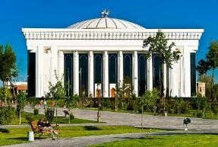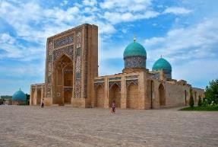

# Day 2, Fri: Bukhara B/L/D

At first you will visit the most ancient citadel in Bukhara dating back to the 4th century named Citadel Ark which served as a palace for several dynasties of Bukhara Empire. Then you will see Samanids mausoleum, a real masterpiece of architecture of 9th -10th century. Then the tour continues to Chashma Ayub, meaning Job's well and Bolo-Hauz mosque, known also as the mosque of forty columns built in honor of Bukhara governor Abu-Fayud Khan. Then you have a chance to walk along the shopping domes and visit one of the most famous madrasahs of Bukhara called Nodir Divan Begi which is also a part of Lyabi House Ensemble, famous central

sightseeing of Bukhara. The tour will end with visiting Poi Kalon complex, the unique sample of architectural art of Bukhara. It consists of three structures built in the 12th - 16th centuries: Kalon minaret, Kalon mosque and Mir Arab Madrasah. Dinner will be at national restaurant, following by dancing show program. Overnight.

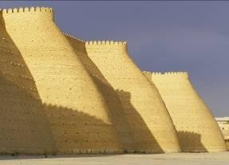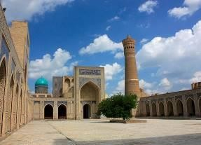

# Day 3, Sat: Bukhara – Gijduvan – Samarkand B/L/D

After breakfast, we will start our way to Samarkand. We will stop over at Gijduvan village to visit famous private pottery workshop. Gijduvan ceramics school has its deep roots. The skills have been passed from father to son from generation to generation. Today Gizhduvan is home for the sixth generation of potters from Narzullayevs family which glorified Gijduvan school ceramics all over the world. Gijduvan School of ceramics is distinguished by a geometric pattern. Green and blue colors prevail in decoration of products. On the way visit memorial complex of Al Bukhary. Al Bukhary was an Islamic scholar, who authored the hadith collection known as Sahih al-Bukhari, regarded by Sunni Muslims as one of the most authentic Hadith collections. Afterwards we continue driving to Samarkand. Dinner and overnight.

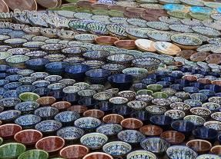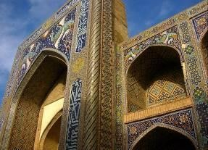

# Day 4, Sun: Samarkand B/L/D

Samarkand is situated in the valley of the river Zerafshan. It is the second largest city of Uzbekistan and is of the same age as the city of Babylon or Rome. Today you will visit its most outstanding sights such as Registan square, Shakhi-Zindeh, Mausoleum Guri Emir and Bibi Khanum Mosque. Registan Square, a complex of three fascinating Madrasahs dating back to 15- 17th centuries, is the main highlight of Samarkand that no person can stop admiring its beauty and majesty. Architectural complex of Shakhi-Zindeh represents a big collection of mausoleums dating back to 11th-15 centuries being a part of a UNESCO World Heritage Site. Bibi Khanum

Mosque was built in honor of favorite Tamerlane’s wife, after his successful campaign in India. Dinner and overnight.

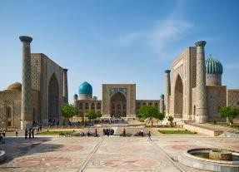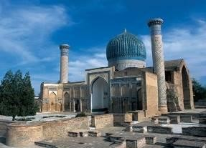

# Day 5, Mon: Samarkand – St.Petersburg (Morning flight) B/L/D

Breakfast is at the hotel. Transfer to the Airport. Depart for St. Petersburg city, Arrival Saint Petersburg Meet by your escort guide and transfer to the hotel. City tour in Saint Petersburg: During the tour, you will be taken out on the extra-comfortable bus, which will take you to the most precious monuments of the city’s rich history and original architecture carefully preserved as the world cultural heritage. During this panoramic city-tour of Saint Petersburg, you will be able to hear amazing stories and to take fine pictures of the main architectural and historical sites like Nevsky prospect, the Kazan Cathedral, the Winter Palace, Vasilievsky Island, St. Isaac Cathedral, Peter and Paul Fortress, the Senate Square and the Palace Square Lunch and dinners are at local restaurants. Overnight is at the hotel.

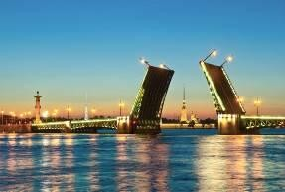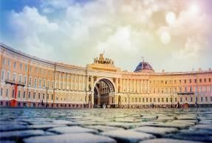

# Day 6, Tue: Saint Petersburg – Tashkent (Evening flight) B/L/D

Breakfast is at the hotel. City tour in Saint Petersburg: Hermitage Museum (main building). It is hard to imagine a trip to Saint Petersburg without visiting one of the most famous museums worldwide – the State Hermitage. Its priceless collection occupies five historical buildings of which the Winter Palace – the former residence of the Russian Royal family – is the most remarkable. Its rooms, decorated with marble and gold provide a fine background for the treasures of the Hermitage. Lunch will be at local restaurant. Kazan Cathedral - was built in 1811 and is usually associated with Russia’s victory over Napoleon in 1812. Transfer to Airport. Depart for Tashkent.

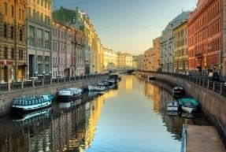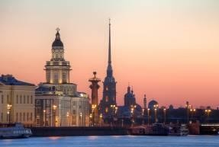

# Day 7: Wed: Tashkent – departure

Arrival to Tashkent. Transit and depart for next destination.

# Travel Map:

# 

**Type of transport:**

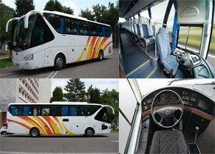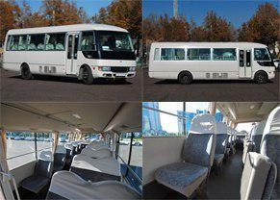

# Pricing



|  |  |  |
| --- | --- | --- |
| **Persons** | **Price per person in USD** | |
|  | **Option A** | **Option B** |
| 15+1 Foc | 685 | 805 |
| 20+1 Foc | 635 | 750 |
| 25+1 Foc | 620 | 735 |
| 30+1 Foc | 585 | 695 |
| 35+1 Foc | 570 | 690 |
| 40+1 Foc | 560 | 670 |
| Single Supplement | 150 | 250 |

|  |  |  |  |
| --- | --- | --- | --- |
| **Cities** | **Nights** | **Option A** | **Option B** |
| Bukhara | Two | Porso 3* | Omar Khayam 4* |
| Samarkand | Two | Ideal 3* | Diera 4* |
| St. Petersburg | One | Okhtinskaya 3* | Moscow 4* |

**Price includes:**



Accommodation at mentioned hotels on double share basis

Transportation per program in comfortable a/c transport with professional drivers Breakfasts at the hotels

All show programs and master classes per program

All meals as per program

Daily three bottles of 0.5l water per person

Group tour leader in single room free of charge (+1 Foc)

Escort English speaking (Bahasa is as per request) professional guide for entire tour Entrance fees to mentioned sights per program (excluding photo and video charges at sights)

# Price does not include:

Visa consular fees and processing expenses Professional photo and video charges at sights International air tickets to / out of Tashkent Travel Insurance

Extras, not indicated in inclusions Early check in at the hotel in Tashkent

# PS:

Pricing valid for contracted partners only for mentioned dates

If mentioned hotels are overbooked or not available, we will give appropriate alternative. If there is no free seats in bullet train, we will replace by normal train.

# Payment:

 Tour payment should be made not less than 40 days prior to tourist group arrival to our bank account as per sent invoice.

 The rooming list should be finalized 30 days before arrival.

# Cancellation fees:

No charges up to 45 calendar days up to tour starting date

50% of full package price up to 14 calendar days up to tour starting date

100% of full package price – 7 or less working days up to tour starting date or no show.